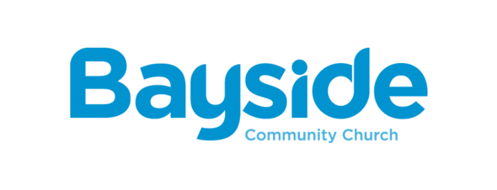

www.baysidecc.com.au

Bayside Community Church – Lead Pastor
Bayside Community Church is an intergenerational contemporary church in the heart of Sydney next to Sydney Olympic Park. The cultural diversity of the church is reflective of the surrounding suburbs of Rhodes, Concord West, Wentworth Point, Homebush and Newington.
We are prayerfully seeking a new Lead Pastor who will provide overall leadership to the church, which will include building and leading a staff team, and empowering the Bayside community to fulfil its mission to love God and love people, encouraging others to grow with us into passionately committed followers of Jesus.
The role of Lead Pastor calls for someone who exhibits strongly missional leadership, and who can lead the church with that emphasis. The Lead Pastor will oversee the leadership of a range of existing ministry areas, and identify, resource and nurture potential new ministries and congregations with the mission of reaching and engaging with Bayside’s surrounding communities.
Note that Bayside Community Church is an affiliated Baptist Church with the Baptist Churches of NSW & ACT.

We seek a candidate with the following ministry skills:
- Leadership: proven ability to act as a ‘leader of leaders’ and to empower others to use their giftings.
- Teaching: demonstrated effectiveness in conveying the truth of the Bible in a variety of contexts.
- Communication: good listener, engaging, and able to communicate effectively with people from a variety of cultural backgrounds and generations.
- Discipleship: demonstrated skills in and commitment to making disciples.
- Mission: commitment to community engagement and outreach to those who don’t yet know Jesus. This includes the capacity to recognise opportunities and lead the church in engaging with them.
- Openness to non-traditional expressions of church: demonstrated ability to minister across a variety of contexts; openness to innovation and creativity.
- The candidate must be either already accredited by the Baptist Association of NSW & ACT, or eligible to apply for Accreditation or Recognition with the Association. If not already Accredited or Recognised, he or she would need to commence the process within the first three months of employment at Bayside.

For 40 days (27th July – 4th September 2020) the whole church community committed to praying every day for the leader and his or her family that God has in store for Bayside. We have prayed for our ministries, the community and for every person who is a part of Bayside. A significant part of our 40 days in prayer has involved asking God to prepare our hearts to receive and care for the next lead pastor and their family, so that we can partner together in ministry and mission.

Enquiries and Applications
To find out more about this position, or to request copies of the Bayside Church & Community Profile and Leader Pastor Profile, please contact James Burton at jimmyburton95@gmail.com

To apply, please submit the following documents to James Burton at the above email address:
- A cover letter that addresses the question: What has led you to apply for this role?
- An up-to-date Curriculum Vitae
- Your Ministry Profile.
We want to know about your past experiences, your formal qualifications, God’s call on your life, and your reason for applying for this role.

Please submit your application by close of business on 31 October 2020. Note that the application period may end earlier if it is discerned that God has raised up the right leader.

