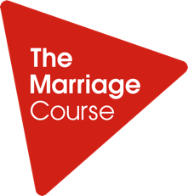
Registration for The Marriage Course Online
Mondays, 12th October - 23rd November, 7pm
Name:
Email:
Phone:
Partner's name:
Partner's email address:
Partner’s Phone:
Your age range: Under 30 30-39 40-49 50-59 60+
Your partner’s age range: Under 30 30-39 40-49 50-59 60+
How did you hear about the course? (Write ‘YES’ next to ones that apply)
- Recommended by a church
- Referred by counsellor, doctor or pastor
- Personal recommendation
- Press
- Websearch
- Social media
- The Marriage Book
- Alpha
- Other: ____________
Please indicate ‘YES’ next to the description that best describes the relationship status between you and your partner:
- Married
- Unmarried and cohabiting
- Engaged
- Dating
- Other
How many years have you been married? (If not married, how many years have you been together?)
Do you attend a church? (YES/NO)
If 'Yes', please specify the church you attend _______
Are you happy for us to contact you in the future about other courses that we run? (YES/NO)

