Adding COVID-19 Digital Certificate from Individual Healthcare Identifier
If you don’t have Medicare, you can still add your COVID-19 digital certificate to your Service Victoria app from myGov using your Individual Healthcare Identifier (IHI).
- Sign in to your myGov account(External link) using a browser on your device.
- Select the ‘Individual Healthcare Identifiers’ service.
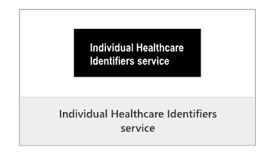
- Select ‘View immunisation history’ on the ‘Immunisation history’ tile..
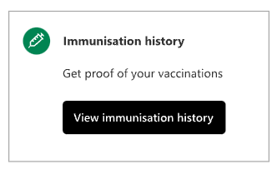
- Tap your name and ‘Share with check-in app’.
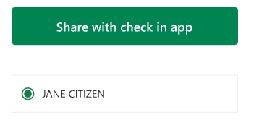
- Tap ‘Service Victoria’.
- Once you’ve read the conditions, tap ‘Accept and share’. You’ll see the message: ‘Sending certificate’.
- Once you see your COVID-19 digital certificate, tap ‘Add certificate’.
- Your COVID-19 digital certificate is now added to your Service Victoria app and linked for QR code check-in.
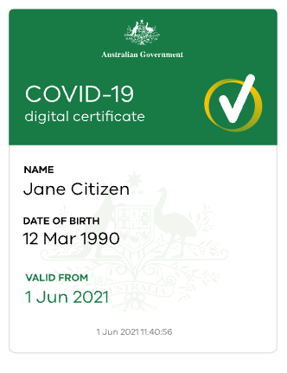
If you’re using an iPhone or Apple device, you can use either the Safari or Chrome browsers. If you’re using an Android device, you’ll need to use the Chrome browser.
You can get information from the Services Australia website about getting proof of your COVID-19 vaccinations online if you’re not eligible for Medicare(External link).

