Adding COVID-19 Digital Certificate from Express Plus Medicare app
- Make sure you have the Express Plus Medicare app. You can download it from the App store(External link) or Google Play store(External link).
- Download/Update your Service Victoria app at the App store(External link) or Google Play store(External link).
- Open the Express Plus Medicare app.
- Tap ‘Proof of vaccinations’.
- Tap 'View history'.
- Tap 'Share with check in app'.
- Tap ‘Share’ next to Service Victoria.

- Read the conditions, then tap ‘Accept and share’.
- Tap ‘Add certificate’.
- If you see a screen which says ‘Show your COVID-19 digital certificate with an orange button at the bottom which says ‘Add certificate via myGov’ tap ‘Close’ in the top left corner.
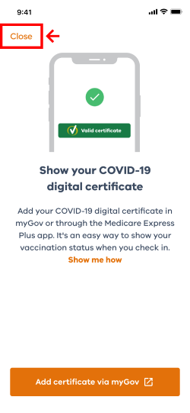

- Your COVID-19 digital certificate is now added to your Service Victoria app and linked for QR code check-in.
