TEMPLATE
BUV Child Safety Assessment Tool 2022 – Victorian Child Safe Standard 1
Purpose
The purpose of this tool is to assist BUV churches to self–assess their compliance with the 11 Victorian Child Safe Standards to ensure that child safety is embedded within, and reflected by, the culture of the church, its leadership and its ministries. This self-assessment tool also enables churches to document their progress in relation to creating safe environments for children and young people.
About the Self–Assessment Tool
This self-assessment tool is based on the CCYP Victorian Child Safe Standards (CSS), specifically Standard 1 Organisations establish a culturally safe environment in which the diverse and unique identities and experiences of Aboriginal children and young people are respected and valued. The criteria noted for Standard 1 reflect the foundation steps for this standard identified by CCYP. This document reflects the same requirements as found in existing CCYP documentation and other templates currently available via the BUV website, however includes more suggestions of concrete suggestions to include, documents to refer to, and a more detailed way to measure your progress at achieving each dot point.
The Self-Assessment Tool is a MS Word document and is designed to be printed on A3-size paper.

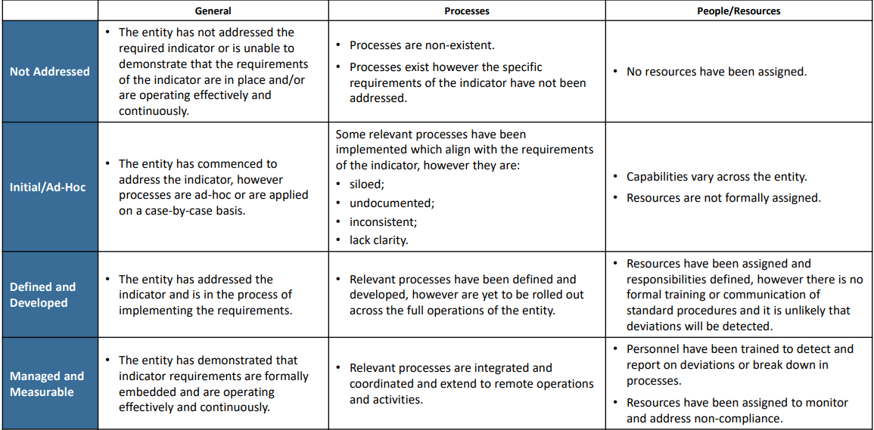
How to use the Self–Assessment Tool

The Self-Assessment Tool requires each church to assess themselves against each indicator.

In addition, for each indicator, the following questions will need to be answered:
      - What is already in place? What evidence do we have of this?
- What more do we need to do?
- Who is responsible? What is the timeframe?

Answers for each questions should be comprehensive and include any activities that are in progress, planned or not implemented.

Please note: If your church believes an indicator is Not Applicable, please provide an explanation within this document.

Standard 1: Our Church establish a culturally safe environment in which the diverse and unique identities and experiences of Aboriginal children and young people are respected and valued.
Criteria | Indicator requirements | Not Applicable | Not addressed | Initial / Ad Hoc | Defined & Developed | Managed & Measurable | What is already in place?  What evidence do we have of this? | What more do we need to do? | Who is responsible?  What is the timeframe?
Criteria 1.1  A child’s ability to express their cultural rights is encouraged and actively supported. | A public commitment to the cultural safety of Aboriginal children is available and displayed for public access.
 | Personnel must encourage and support children to express their culture and enjoy their cultural rights.
The Code of Conduct and position descriptions outline behavioural expectations of all personnel including:
zero tolerance of racism and expectations that personnel will act to prevent and report incidences of racism.

Criteria 1.2  Strategies are embedded within the church, that equip all personnel and members of the community  to acknowledge and appreciate the strengths of Aboriginal culture and understand its importance to the wellbeing and safety of Aboriginal children and young people. | Personnel are strongly encouraged to actively support and facilitate the inclusion and participation of Aboriginal children and their families within the life of the church.
 | The church identifies steps already taken to guide or train personnel and leaders to understand, respect and value Aboriginal culture and to understand the importance of this to the wellbeing and safety of Aboriginal children
 | The church identifies steps already taken to recognise and celebrate Aboriginal peoples, their achievements, communities and cultures.
Criteria 1.3  Measures are adopted by the church to ensure racism within the church is identified, confronted and not tolerated. Any instances of racism are addressed with appropriate consequences. | The Safe Church policy/Child Safety policy (or similar name) describes the church’s commitment to respecting and valuing Aboriginal children, whilst addressing how racism will not be tolerated and how instances of racism will be responded to, including potential consequences.
 | The Code of Conduct and position descriptions outline behavioural expectations of all personnel, including that children will be supported to express their culture and enjoy their cultural rights.
 | The church identifies steps already taken to ensure racism within the church are consistently identified and appropriately addressed.
Criteria 1.4  The church actively supports and facilitates participation and inclusion within it by Aboriginal children, young people and their families. | A public commitment to the cultural safety of Aboriginal children is available and displayed for public access.
 | The church leadership helps all personnel and members of the community, to acknowledge and appreciate the strengths of Aboriginal culture and understand its importance to the wellbeing and safety of Aboriginal children.
 | The church identifies steps already taken to actively support and facilitate participation and inclusion of Aboriginal children and their families
Criteria 1.5  All of the church’s policies, procedures, systems and processes collectively create a culturally safe and inclusive environment and meet the needs of Aboriginal children, young people and their families. | A public commitment to the cultural safety of Aboriginal children is available and displayed for public access.
 | Policies and procedures relating to child safety and wellbeing, including the Safe Church policy/Child Safety policy (or similar name) describes the church’s commitment to respecting and valuing Aboriginal children.
 | The church identifies steps already taken to create a culturally safe environment for Aboriginal children.

